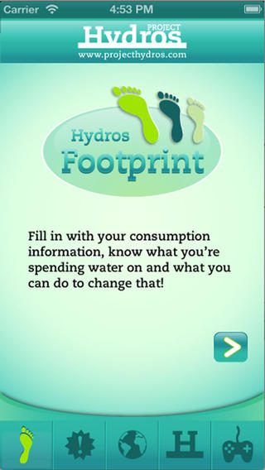**Groupassignment Hydros Footprint**   
  
Do you have any idea how much water you are using on one day?  
Make your own water footprint. Go to the nextwebsite and install the app on your mobile phone.

<http://www.projecthydros.com/pegada>

1. Open Hydrosfootprint and push the button > and give the right   
 answers on the questions.

2. a. What is your waterconsumption per year? _______________________  
 b. Do you use more or less water than most people in the word? ______________________________________________________________

3. Push on the button with a !.   
 This part will give you information how we can reduce the   
 consumption of water.  
 a. Summarize the different ideas:  
_____________________________________________________________________________________________________________________________________________________________________________________________________________________________________________________________________________________________________________________________________________________________________________________________________________________   
 b. Discuss in your group which ideas are in your opinion most easy to apply by   
 yourself: ___________________________________________________________________________________________________________________________________________________________________________________________________________________________________________________

4. Push on the button with planet earth.  
 a. How much % of our planet is covered with water? _________________________________________________________________________________  
 b. How much % of this amount is available for human consumption? _________________________________________________________________________________

c. Discuss in your group what is the problem with the amount of water available   
 for human consumption and try to give some answers how to reduce these problems.  
______________________________________________________________________________________________________________________________________­­­­­­­­­­­­­­­­­­­­­­­­­­­­­­­­­­­­­­­­­­____________________________  
___________________________________________________________________________________________________________________________________________________________________________________________________________________________________________________

d. How will the future of consuming of water will be in 2025 if we go on with   
 consuming water like we are doing now?  
____________________________________________________________________________________________________________________________________________________________________________________________________________________________________________________________________________________________________________________________________   
_________________________________________________________________________________